Software Engineer (Backend)

* MongoDB/Nodejs
* JavaScript
* Python

Zoomi Technologies Inc

* Mobile Apps
* Web Apps
* Enterprise Solutions

Data structures

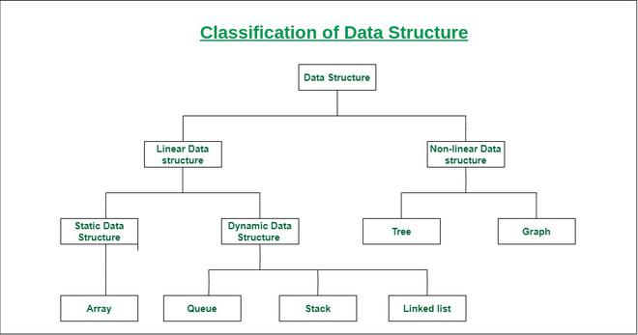

OOP OOP: Object Oriented Programming

* Programming model that organizes software design aroud data or objects rather than functions and logic
* Inheritance - Inheriting attributes and methods of another class
* Encapsulation - Hides data from outside access
* Polymorphism - Function having same name but carrying different functionalities
* Data abstraction - Hiding internal details of a function and showing its functionality only

Database and version control

Salary

* 150,000LKR/month
* Negotiable if necessary

Tell me about yourself

* Name, age
* School
* University
* Batch Rep, Extra curricular work
* Career change, finished academic work, self-studying, looking for opportunities

Why did you change the career path?

* Didn’t make the cut, Economic crisis, not a lot of jobs in electrical field, vaccum in computer science field, department 50 from 100